Årre, August 2021

Due diligence and Code of conduct in Kvist Industries A/S

At KVIST we work with the FSC certification, EU and Nordic Swan Ecolabel as well as the ISO 9001 quality management system.
KVIST works closely together with our suppliers and partners to make sure legal demands are fulfilled.
- REACH (the European Agency for Registration, Evaluation, Authorisation and Restriction of Chemicals
- EUTR (the European Timber Regulation)
- Proposition 65 (American chemical regulation)
- Formaldehyde emission limits (European and American)
- Flammability standards (European, American and British)
Kvist Industries A/S works with and by the 10 principles in the UN Global Compact and set the same requirements to our suppliers.
- Health and Safety
- Handling of chemicals
- Child labour
- Environment
- Working hours and wages
- Workers basic rights
- Legal compliance
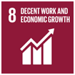
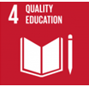
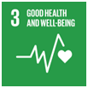
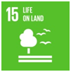
Kvist Industries is working strategically with 6 of the 17 UN Sustainable Development Goals.

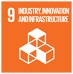
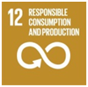
Kvist Industries supply Nordic Ecolabel and EU Ecolabel products to customers through our certifications.
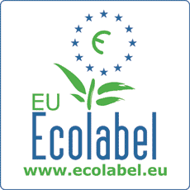
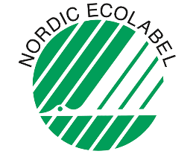

Michael Eirup
HQSE manager
Kvist Industries A/S

